Lesson 10.4 Newton’s third law of motion

Recommended teaching time for this lesson: 1 x 60 minute period

• 35 minutes of explicit teaching

• 25 minutes of suggested classroom activities

• 30 minutes homework

Getting started

Key ideas

* Newton’s third law of motion states that whenever one body exerts a force on a second body, the second body exerts an equal and opposite force on the first.

Curriculum links

Science understanding

* Describe the three laws of motion of classical mechanics and give examples of each.
* Solve problems using of the laws of classical mechanics and $a=\frac{F_{net}}{m}$.

Advice for teaching this lesson

Things to know before you start teaching

It can be useful to have some extra items in the room to demonstrate force pairs such as magnets, objects hanging from ropes, or electrically charged objects like straws rubbed with wool.

Even if you don’t plan on using the activity with the Veritasium video it is worth watching for yourself. A common misunderstanding for students – even at the university level – is that force pairs are just pairs of equal forces, rather than the same force interacting between two objects.

Common misconceptions

* Students often think of Newton’s third law as an action-reaction pair, which implies an amount of time between the reaction. Students should understand that forces are simultaneous and no ‘signal’ is transmitted between them.

Differentiation strategies

For students who are having difficulty with identifying force pairs, have them recall the following two principles:

1. A force pair is always the same type of force. Gravity with gravity. Magnetic with magnetic. While some forces will equal, such as gravity and normal this does not make them a pair.

2. If the statement ‘Earth applies gravity to the moon’ is true, then the nouns can be swapped and also be true: ‘Moon applies gravity to the Earth’.

Starter activity: Push and pull

Approximate time: 5 minutes

**Activity placement:** Place directly after Lesson overview

**Activity summary:** A kinematic activity to get students to feel the action of Newton’s third law.

Notes for the teacher

Encourage students to be sensible with the partnered parts of the physical activity.

You could demonstrate this yourself if you wanted to act exuberantly. Run into a wall and bounce off it. The students will remember that.

Instructions for students

Step 1: Find yourself a section of clear wall space.

Step 2: Push against the wall with both hands using short, sharp pushes, as if you are trying to shove the wall over.

* 1. Describe what you feel in your hands and arms as you push into the wall. Don’t be gentle!

Step 3: Find a partner who you are comfortable holding hands with.

Step 4: Each person should lean back away from each other. Try to stay upright using only the hand hold you have with each other.

b. Describe what you feel in your hands and arms as you pull.

Answers

1. Student answers will vary. The intent is that they can feel the force rebound into their hands and arms.
2. Student answers will vary. Students should be able to feel a pull in their arms.

Classroom activity: Cause and effect

Approximate time: 10 minutes

**Activity placement:** Place directly above “Check your learning 10.4”

**Activity summary:** A video addressing a common misconception about Newton’s third law and misattribution of cause and effect.

Notes for the teacher

The video is: <https://www.youtube.com/watch?v=8bTdMmNZm2M>

Please address to the class that the moon does not affect women.

Ask students at the end if they caught the physics joke about the speed limit changing to ‘c’.

Instructions for students

Step 1: Watch the following video of Veritasium on Newton’s third law.

Best Film on Newton's third law. Ever <https://www.youtube.com/watch?v=8bTdMmNZm2M>>

1. Describe the misconception that most people had about the force of the Moon on the Earth compared to the force of the Earth on the Moon.
2. Explain the missing component of people’s understanding of Newton’s third law.
3. Do you exert the same force of gravity on the Earth that the Earth does on you?

Helpful hints

* Rewatch the section involving the drawings of masses with force arrows if you are stuck on question b.

Answers

1. Everyone thought that the Moon exerted a much smaller force on the Earth than the Earth did on the Moon.
2. People assumed because the acceleration/movement was less – we don’t notice the Earth wobbling due to the moon – that the force was less, but they forgot that the mass of the Earth is much larger, which resists that force. This is inertia – Newton’s first law of motion.
3. Yes. Same force, different acceleration.

Classroom activity: Force pairs all around you

Approximate time: 10 minutes

**Activity placement:** Place directly above “Check your learning 10.4”

**Activity summary:** Consolidating activity to get students to consider forces as action pairs between objects, rather than a force from A to B.

Notes for the teacher

You could include some extra materials from the lab such as magnets or electrostatically charge up some straws and stick them to the wall for observant students. An object hanging on a rope/string makes for a good tension force to point at.

Instructions for students

Every object you ever interact with involves some sort of force pair. Some will have more than one pair.

1. Identify three force-pairs around you in the classroom. Write the name of the two objects involved and the force between them.

Helpful hints

* Nearly everything involves some sort of force pair.
* You will find a lot of copies of the same type of forces, but try to look for variety.

Support activity

Notes for the teacher

This provides some example forces to consider.

Instructions for students

Macro objects – objects that you work with every day – are commonly affected by contact forces such as applied forces, friction, and tension. There are also the non-contact forces that could affect objects such as gravity or electromagnetism. Everything is affected by nuclear forces within the atoms.

1. Identify three force-pairs around you in the classroom. Write the name of the two objects involved and the force between them.

Challenge activity

Notes for the teacher

This activity asks students to extend their identification by doing free body diagrams.

Instructions for students

Every object you ever interact with involves some sort of force pair. Some will have more than one pair.

1. Identify three force-pairs around you in the classroom. Write the name of the two objects involved and the force between them.
2. Draw your force pairs as a free body diagram.
3. Identify something in the room that is affected by three different forces. Name the forces.

Answers

1. Student answers will vary. The following is a sample answer.  
   Any object resting on another will involve gravity between the object and the Earth. The applied force between the object and the table is another force pair. Magnets pinned to boards will demonstrate a magnetic force pair. Objects hanging from strings (such as mobiles from the roof, or cords for curtains) will demonstrate tension. Everyone sitting down is demonstrating friction between their clothes and the chair.

Support activity

1. Student answers will vary. The following is a sample answer.  
   Any object resting on another will involve gravity between the object and the Earth. The applied force between the object and the table is another force pair. Magnets pinned to boards will demonstrate a magnetic force pair. Objects hanging from strings (such as mobiles from the roof, or cords for curtains) will demonstrate tension. Everyone sitting down is demonstrating friction between their clothes and the chair.

Challenge activity

1. Student answers will vary. The following is a sample answer.  
   Any object resting on another will involve gravity between the object and the Earth. The applied force between the object and the table is another force pair. Magnets pinned to boards will demonstrate a magnetic force pair. Objects hanging from strings (such as mobiles from the roof, or cords for curtains) will demonstrate tension. Everyone sitting down is demonstrating friction between their clothes and the chair.
2. Example diagrams:  
   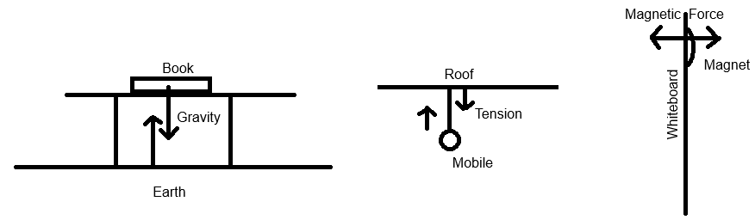
3. Student answers will vary. The following is a sample answer.  
   A student sitting in a chair is affected by three force pairs. Gravity between the student and the earth pulling them down. The normal/applied force from the chair pushing the student back up. Friction between the student’s clothes and the chairs surface to stop them sliding off the chair.